Users requied: roles
Agent
Billing
TL
Auditor
CS
Change Dep
Chargeback Dep
CR Booking

1.
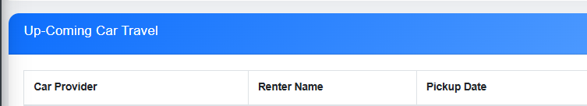
Need to make it clickable, also add CRM ID.

2.
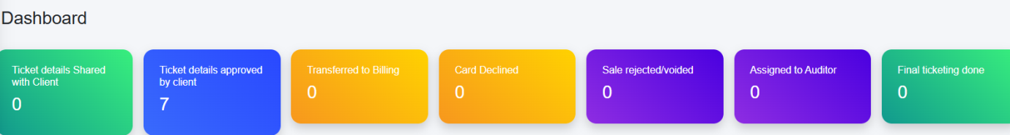
Must show exact counting and also notify about new addition. When case move from one stage to another ,notification should be delivered to the relatable department.
3.
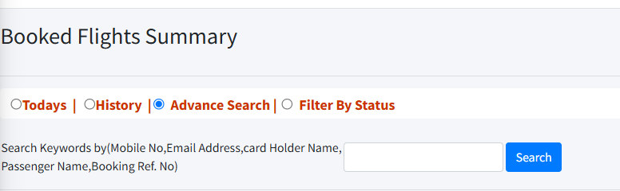
Same search filter should be available in car rental and hotel.

4.
When any existing crm opened it should notify admin and the agent who made that crm.
5.
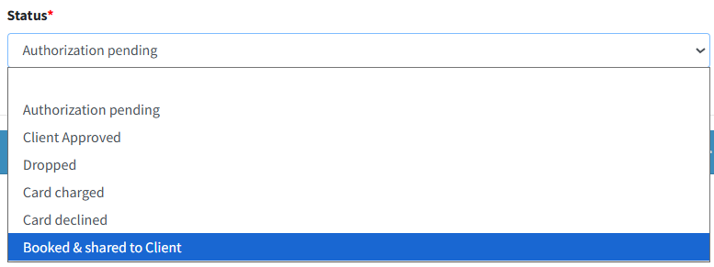

Authorization Pending (By default)
Client Approved
Transfered to Billing(Billing should be notified)
Card Charged(Agent should be notified , green) option only available for Billing
Card Declined(Agent should be notified, red) option only available for Billing
Tag to Change Dep(Change Dep should notify)
Tag to CR Booking(CR Booking should notify)
Tag to Auditor(Auditor and Admin should notify)
QC Done(Notify agent and admin), option only available for Auditor
Tag Refund (Billing)
Tag RDR(Billing and Chargeback)
Tag Chargeback(Billing and Chargeback)
6.
New Addition Future Credit (Only for TL and CS)
Fields required – CRM ID; Customer Name; Voucher Amount, Number of Voucher, Validity
- Notify to that CRM ID agent
Should be visible to Billing, CS, Changes, Chargeback Dep, Auditor

7.
Log report of Booking Process , only for admin

8.
Change templates (Need to provide)
9.
Important: Need database on google sheets on real time.
10.
New Booking Option only opened when the call log filled with Name, Number and Email.
Then Automatic search run in database if duplicate available show Client already existed.
Give option do you still want to proceed? If clicked Yes open new booking form.
11.
IP Whitelisting
12.
Need push notification for each action

deadline – 6 Aug ; testing – 7,8,9 Aug ; live 10 Aug

